Wireshark Lab 5
IT 520-A – Enterprise Infrastructure & Networks
Michael Weiler
Instructions:
In this lab, you’ll be using the traceroute diagnostic tool to packets route across the IP network.
On Windows:
• Go to Command Prompt (start menu, search for “cmd”)
• Type: “tracert www.webawards.com.au”
• Take a full screenshot of your tracert result page
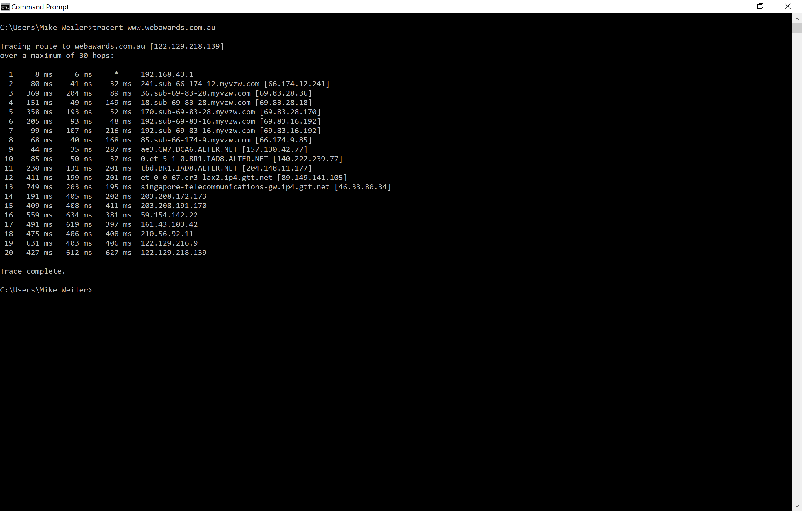
Questions:
- What is your computers IP address? (This is not included in your traceroute results). Take a screenshot of your computers IP address. 174.205.4.124
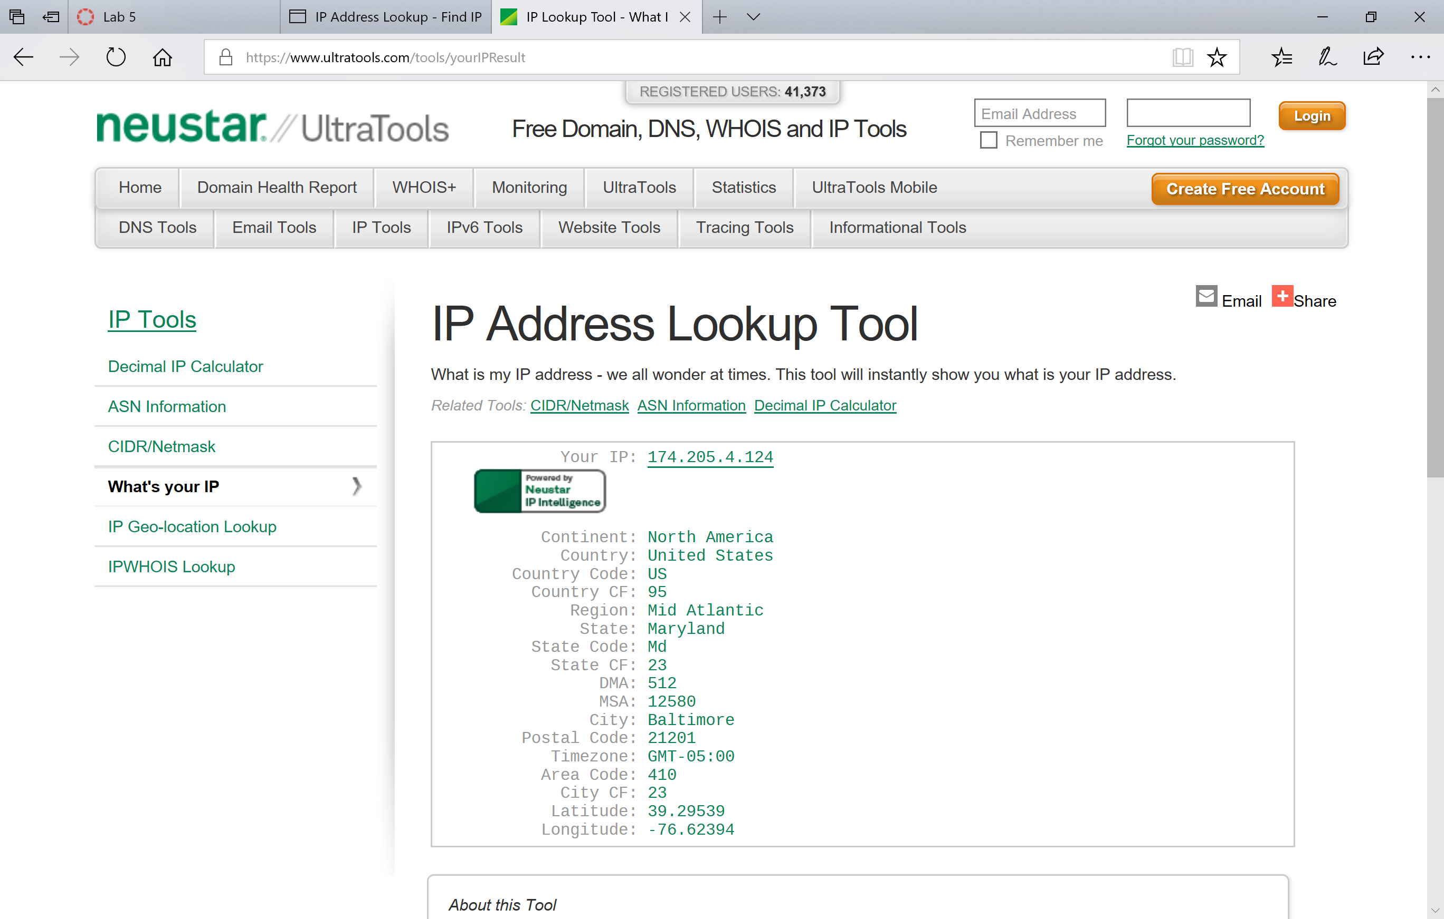
- With reference to private/public IP addresses. What type of IP address is the first IP from your traceroute result. 192.186.43.1 PRIVATE
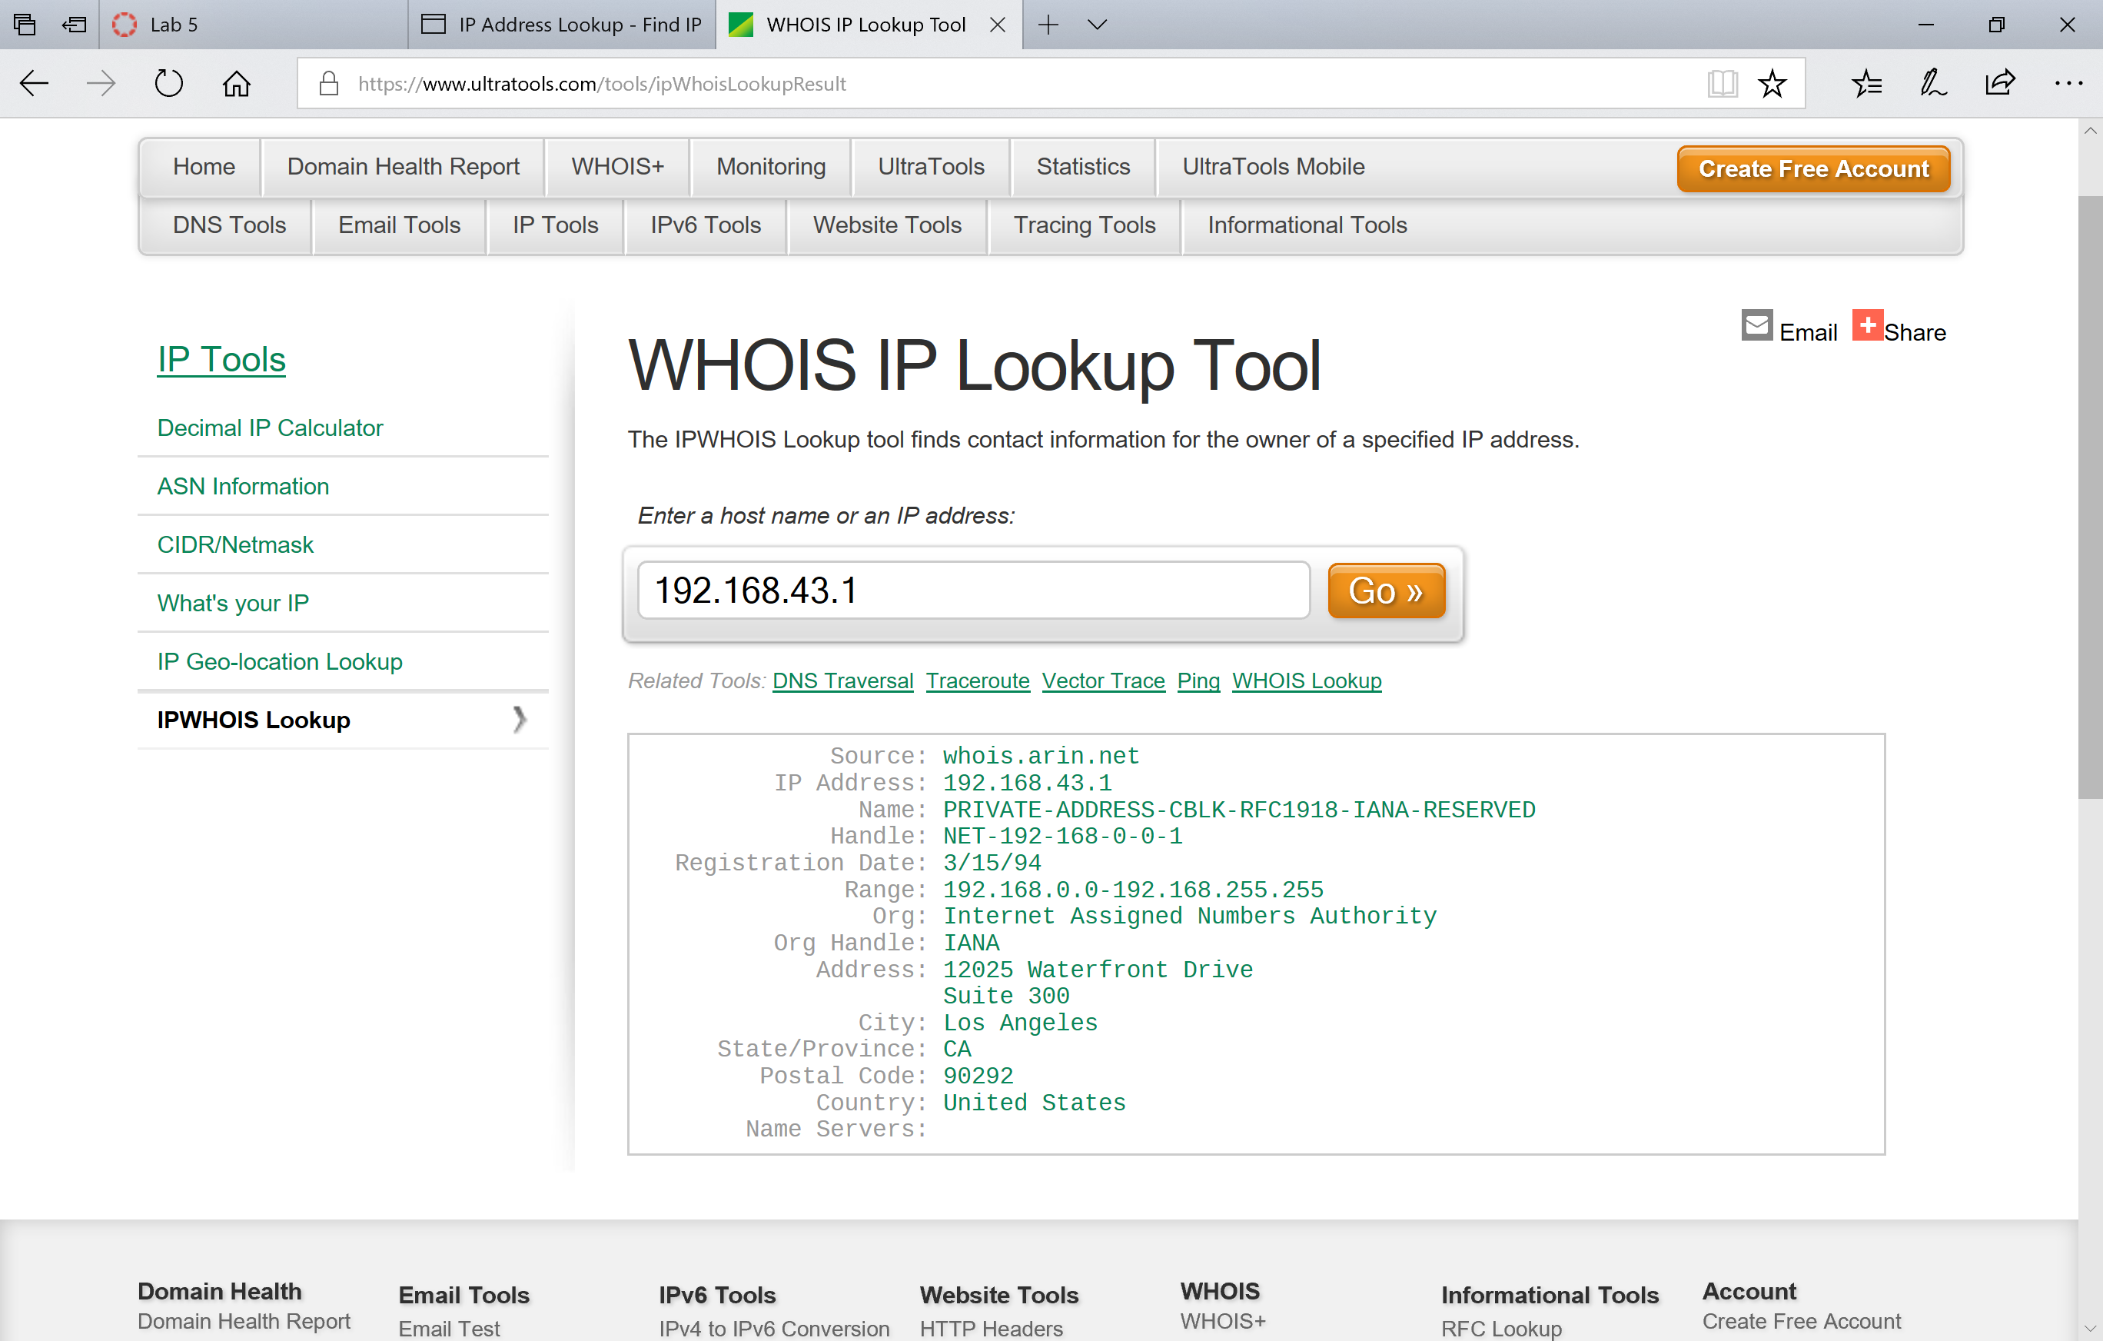
- With reference to private/public IP addresses. What type of IP address is the second IP from your traceroute result. 66.174.12.241 PUBLIC WIRELESS DATA NEWORK
CELLCO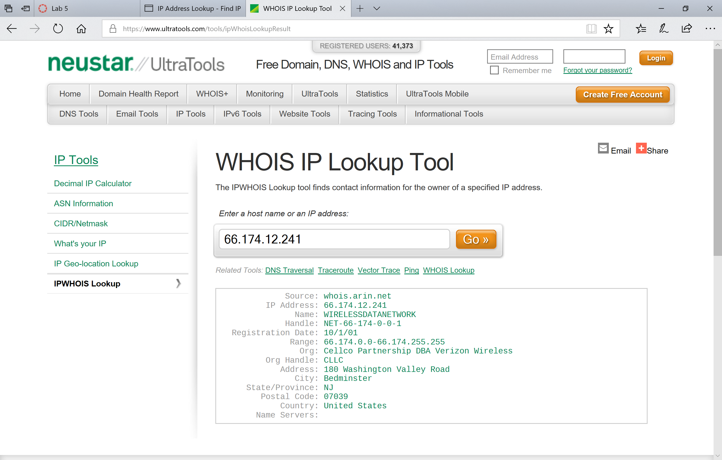
- In a tabular format (use table example below), and in sequential order. Indicate the location of each IP address (include state for US states) and the organization that owns the IP address. (Use https://www.ultratools.com/tools/ipWhoisLookup to look up IP address whois information).
- In your own words, explain everything you just did, and what route did your packet took from source to destination. How many US states did your packet go through? How many countries if any?
I used Tracert to understand the path taken by packets. This shows the number of hops, locations of hops, owners of IPs, and other good info. I have a better understating of how packets go from point a to point B

NOTE: I had so many IPs to look up, I was actually blocked for too many queries!! Hope this does not cost me points…

I had a total of 20 hops in CA, NJ, NY, VA (up unitl it stopped) I did not appear to leave the country.

